C O R P O R A T E P R O F I L E
SANGAM FASTNERS PVT LTD.,


A B O U T U S
Sangam Fasteners Private Limted (SFPL) is an ISO-9001-2015 certified engineering company with an expertise in Machined Components built over the years. SFPL was formed with the vision of manufacturing highly technical and precision components, catering to the needs of Automotive and Non-Automotive sectors including OEMs and TIER-1 Customers. We manufacture machined components.
SFPL’s strong capability in design, engineering and consistency in delivering quality Shafts has resulted in 100 percent retention of the clients. These capabilities give the firm, an edge over its competitors.
We offer our customers cost effective products that conform to international standards. We believe in flawless execution and delivery, so that we can help our customers to thrive in today’s competitive environment.

M I L E S T O N E
Sangam Fasteners Pvt Ltd has been recognized as one of the Top Manufacturers in shaft’s and gets a best supplier award from the IFB.

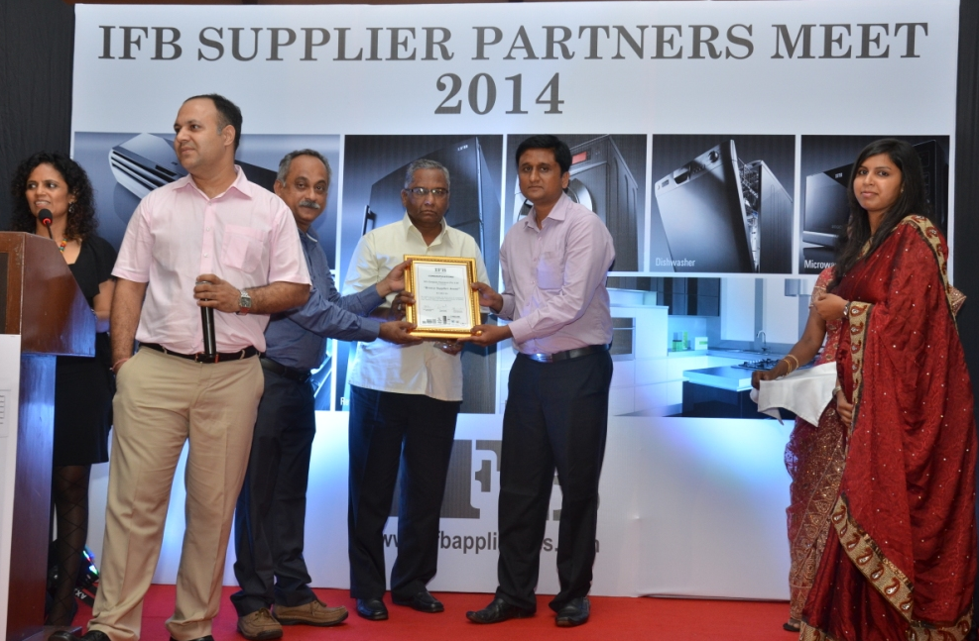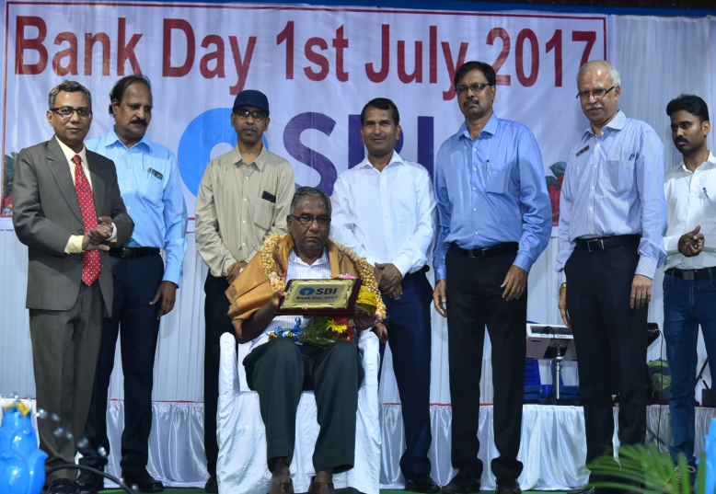
V I S I O N & M I S S I O N


○ Vision

To excel in Machining and Expand the business globally.

S

○ Mission
To create an ethos required to excel in Machining and commit ourselves to the ethics of fair deals.
V A L U E S
○ Ethics ○ Customer Focus

We own our behaviour, keep our Customer Satisfaction is at the
promises, value honest, honour centre of what we do every day.
the community environment in we are trusted partners of our
which we operate and embrace customers.
diversity.
○ Safety, Quality & Well Being ○ Team & Dedication
Exceed industry standards for Dedication to team achieves safety safety and performance by best-in-class solutions in leveraging our core values. Products, Processes and people.
○ Empower & Deliberate
Employees are encouraged to
take action and ensure timely delivery of expectations.
D I R E C T O R

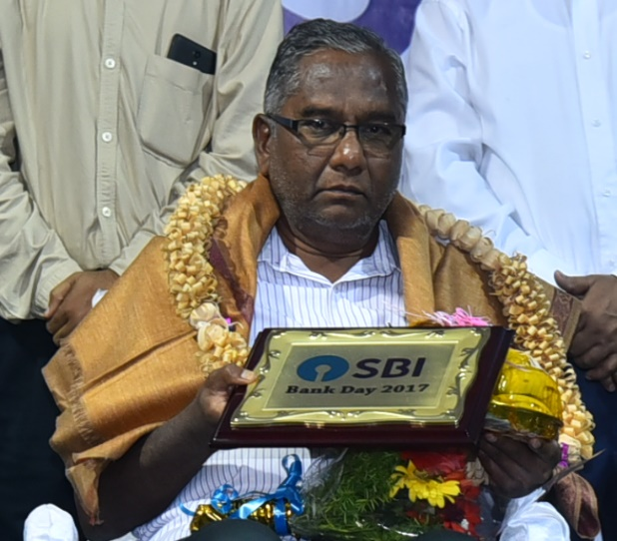

Ishwarappa S Handigol

Chairman

A first-generation entrepreneur and a visionary leader with over 50 years of industry experience. His constant hard work and passion for automobiles & Home Appliance have brought great success.
Sangam Fasteners Private Limited is a reflection of his ambition to maximise customer satisfaction and delivering quality products. He continues to focus on his vision of taking Sangam Fasteners Private Limited to the pinnacle of success and chartering new ways to provide value to his customer.

C E O

Sangamesh I Handigol
CEO
An Graduate, specialised in Marketing. He has a working experience of over 20 years in the family business, during which he had the opportunity to work with companies from varying industries which has helped him understand and serve clients better.
He is currently the driving force of the organisation in implementing newer and modern ways to simplify the business, serve clients better and to make Sangam Fasteners Private Limited a reputed organisation in the market.

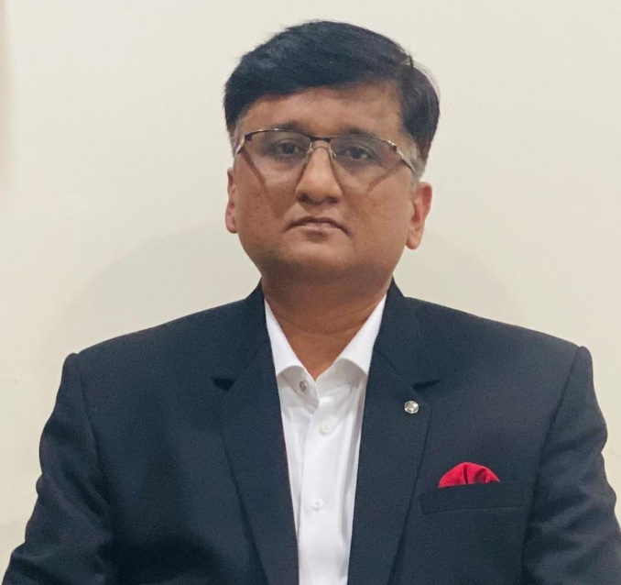
IN F R A S T R U C T U R E

C E R T I F I C A T I O N
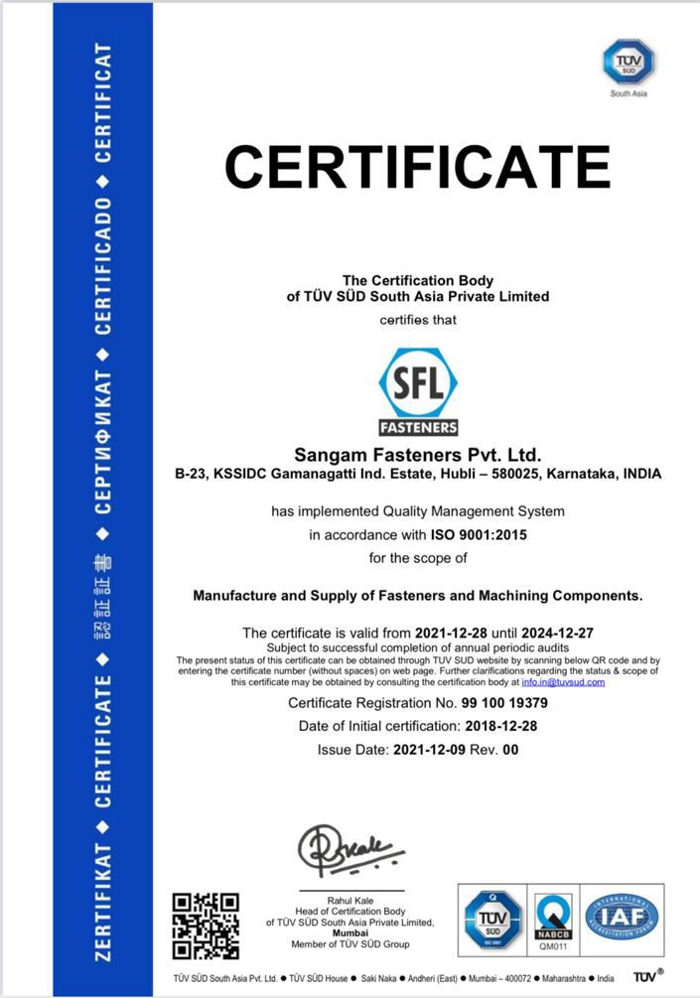
- Sangam Fasteners Private Limited is an ISO-9001-2015
Certified Engineering company with an expertise in machined
Components built over deep experience. We are trusted
Supplier for a variety of customers in industries like
Automotive and non-automotive.

Q U A L I T Y P O L I C Y
- To ensure and enhance customer satisfaction on every occasion through punctual supply of high-quality products.
- To stay committed and comply with international systems and focus on continuous improvement to increase organizational effectiveness.
- To promote innovation by adopting the latest technologies and processes that generates cost-effective solutions.
- To enhance the employees’ skill sets through on-job training and development programs and improves the overall quality of products.
- To carry out inspection and testing for all the products in accordance with Quality Assurance
Plan.

P R O D U T S

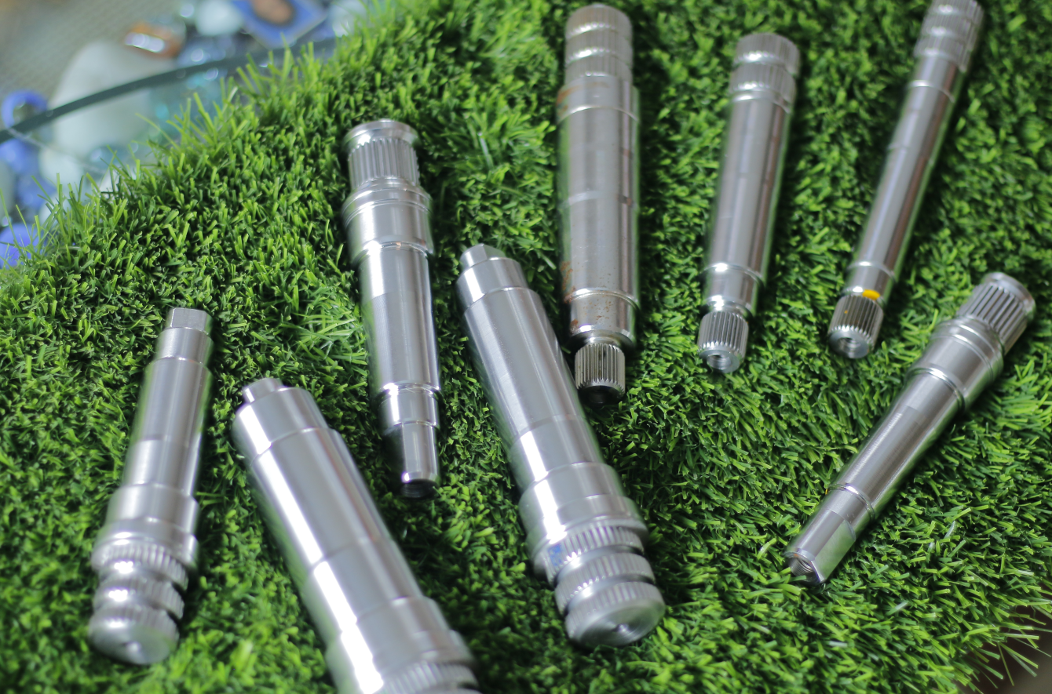

P R O D U C T S

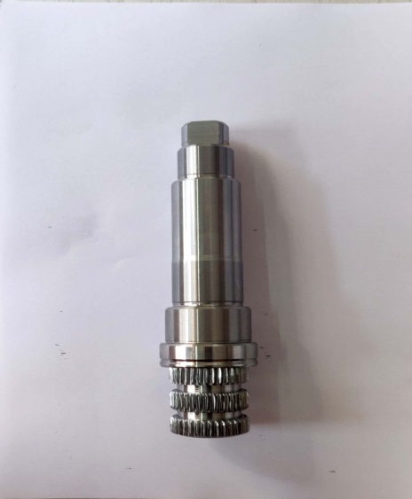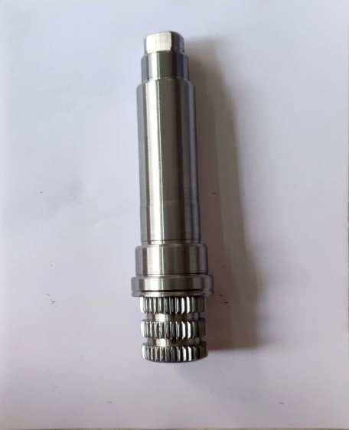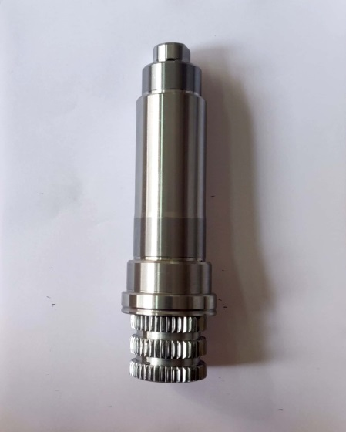
020 (6P) SHAFT 030 (7S) SHAFT 040 (8S) SHAFT

P R O D U C T S

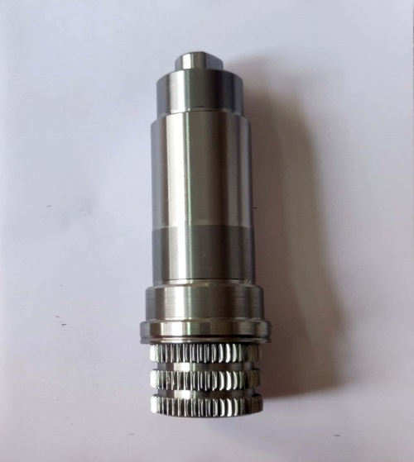 U S 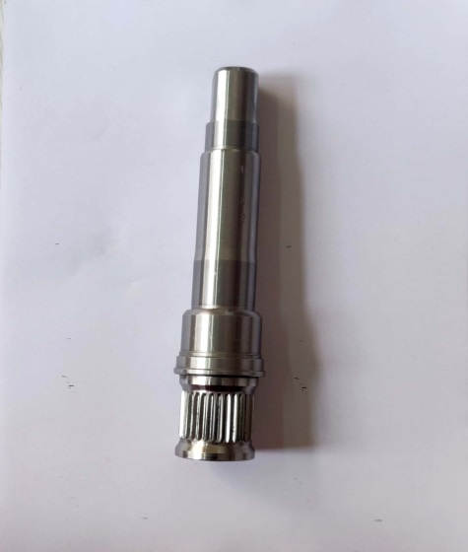 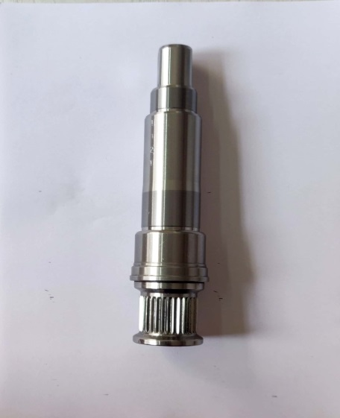
050 (8P) SHAFT 1000RPM SHAFT 1200RPM SHAFT

N E W D E V E L O P M E N T S

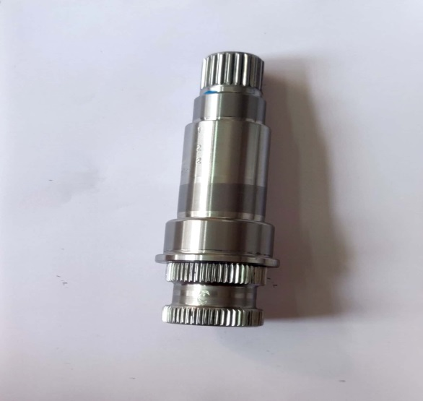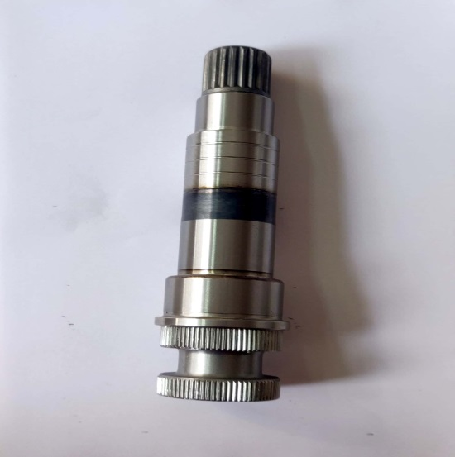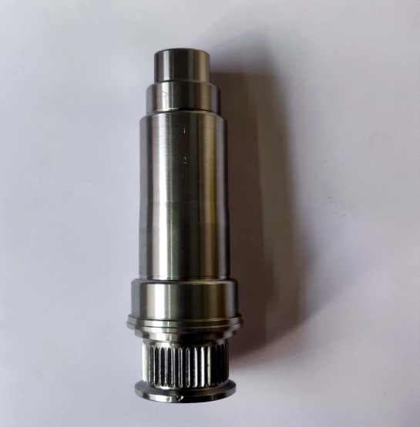
LG-FL440 SHAFT LG-FL550 SHAFT 4000RPM SHAFT

M A C H I N E & E Q U I P M E N T S

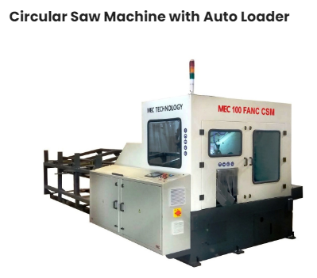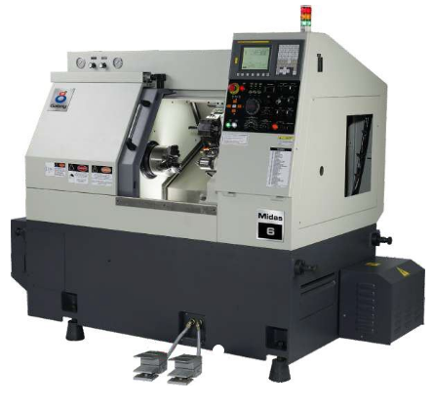
CNC CUTTING CIRCULAR SAW MACHINE CNC TURNING CENTER MIDAS 6

M A C H I N E & E Q U I P M E N T S

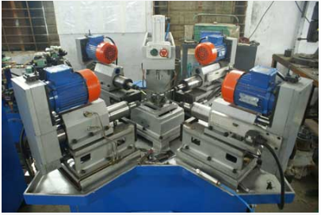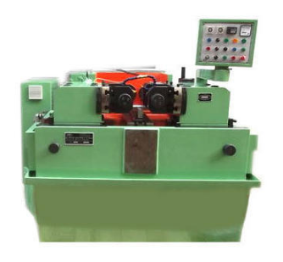
DRILLING & TAPPING MACHINE HYDRAULIC THREAD ROLLING MACHINE

M A C H I N E & E Q U I P M E N T S

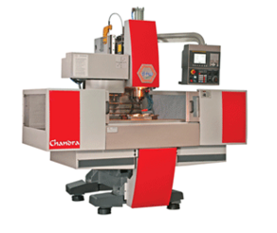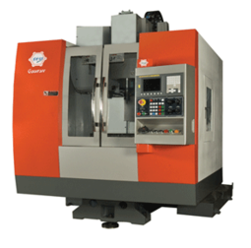
VMC CHANDRA VMC GOURAV

M A C H I N E & E Q U I P M E N T S

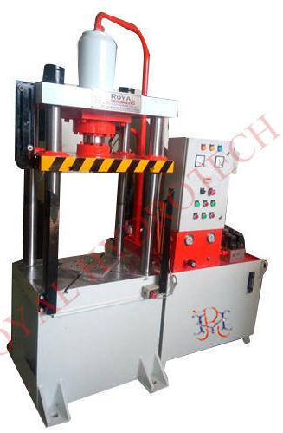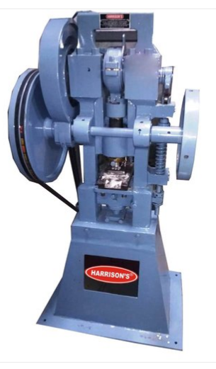
HYDRAULIC PRESSING MACHINE PUNCHING MACHINE

M A C H I N E & E Q U I P M E N T S

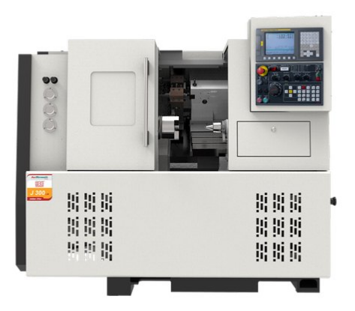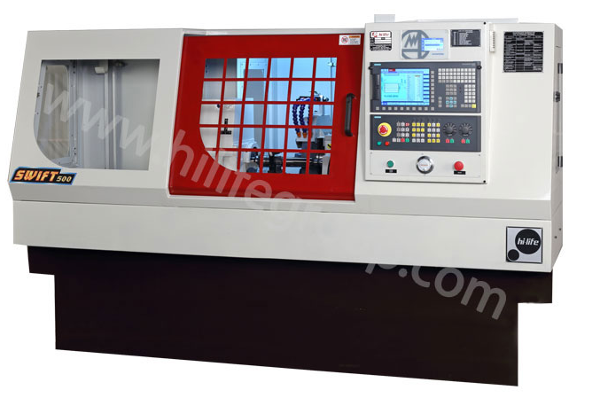
ACE CNC LATHE MODEL: J 300 LM CYLINDRICAL GRINDING MACHINE

M A C H I N E & E Q U I P M E N T S

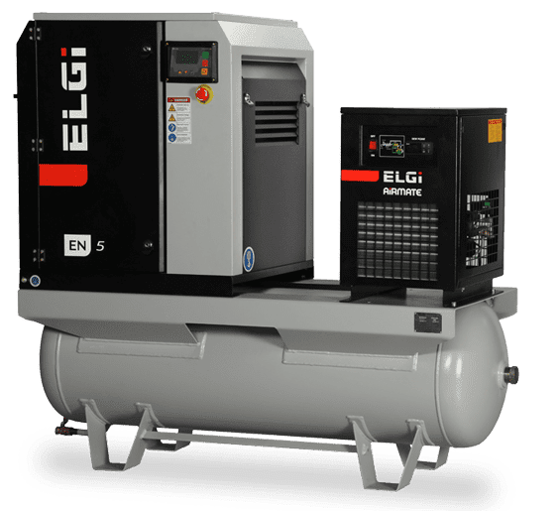
EN SERIES ROTARY SCREW AIR COMPRESSOR

M E A S U R I N G I N S T R U M E N T S

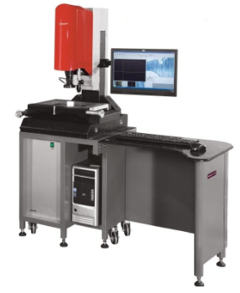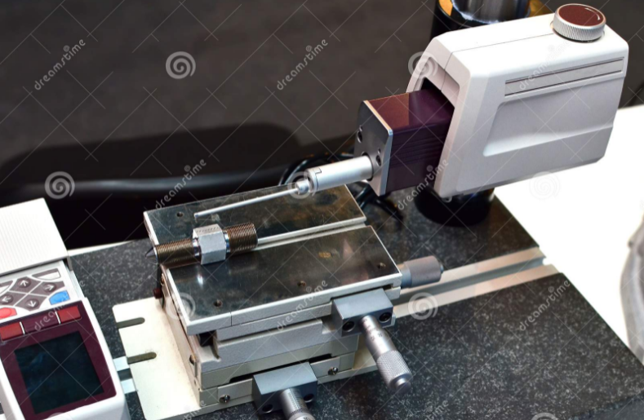

CMM MACHINE SURFACE ROUGHNESS TESTER

M E A S U R I N G I N S T R U M E N T S

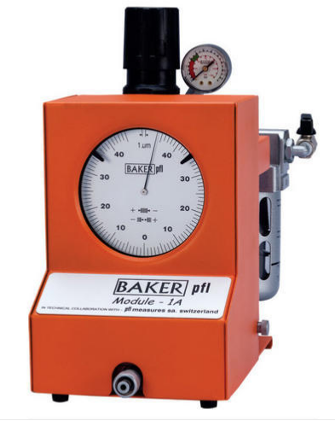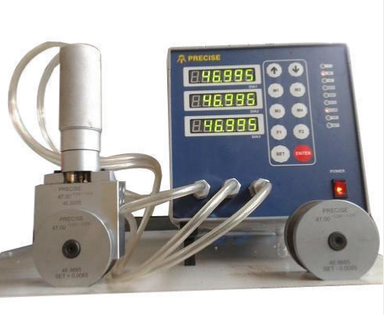

AIR GAUGE DIGITAL AIR GAUGE

M E A S U R I N G I N S T R U M E N T S

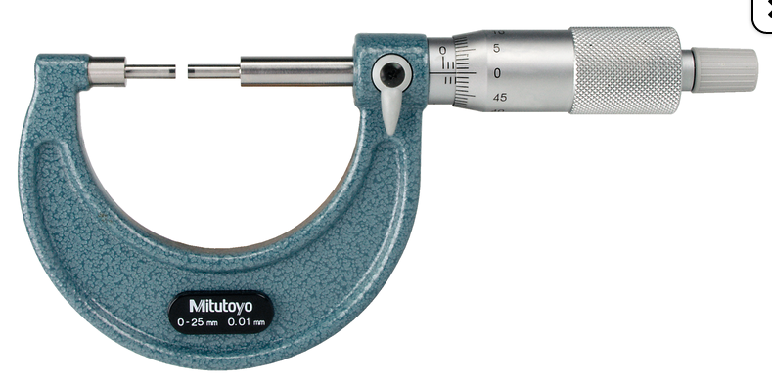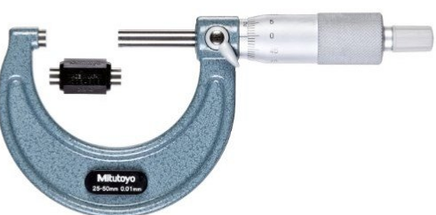

0-25 MM MICROMETER 25-50 MM MICROMET

M E A S U R I N G I N S T R U M E N T

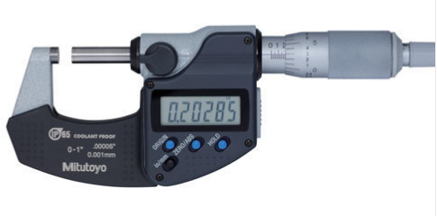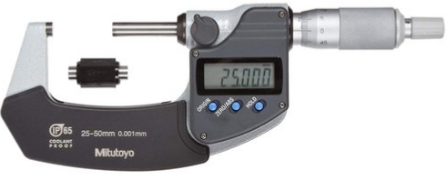

DIGITAL MICROMETER 0-25 MM DIGITAL MICROMETER 25-50 MM

C L I E N T S





C L I E N T S


















R E A C H U S
Sangam Fasteners Private Limited
B-23, KSSIDC Gamanagatti
Industrial Area,Hubli,
Karnataka, INDIA - 580021




+91 9343106083 sf_pl@yahoo.co.in
Sfplapp24@gmail.com
www.sangamfastners.com

